Project Design Phase-II
Technology Stack (Architecture & Stack)

Date | 28 June 2026
Team ID
Project Name | Darshan ease
Maximum Marks | 4 Marks

Technical Architecture:
The DARSHAN EASE – Temple Darshan Ticket Booking System is designed using a three-tier architecture consisting of the Presentation Layer (Frontend), Application Layer (Backend), and Data Layer (Database). The system allows Devotees and Temple Administrators to interact with the application through a modern web interface. User requests are processed by the backend server, which securely communicates with the MongoDB database to store and retrieve temple information, darshan slots, booking details, payment records, and user data.
The architecture includes user authentication using JWT (JSON Web Token), password encryption using bcryptjs, RESTful APIs developed with Express.js, and secure data storage using MongoDB. The frontend is developed using React.js (Vite), which communicates with the backend through HTTP/HTTPS requests. The system also supports role-based access control, ensuring that devotees can book and manage darshan tickets while administrators can manage temples, darshan slots, bookings, and user information. Secure online payment integration, digital QR-code ticket generation, email notifications, and booking history management provide a seamless and reliable user experience.
Example: Darshan Ticket Booking During Festival Seasons
During major festivals and special temple events, thousands of devotees visit temples, leading to long queues and overcrowding. Using DARSHAN EASE, devotees can check real-time darshan slot availability, book tickets online, make secure payments, and receive QR-code e-tickets before arriving at the temple. Temple administrators can monitor bookings, regulate visitor flow, manage available slots, and prevent overcrowding through the admin dashboard. This digital approach reduces waiting time, improves crowd management, and provides a safer and more organized darshan experience for everyone.
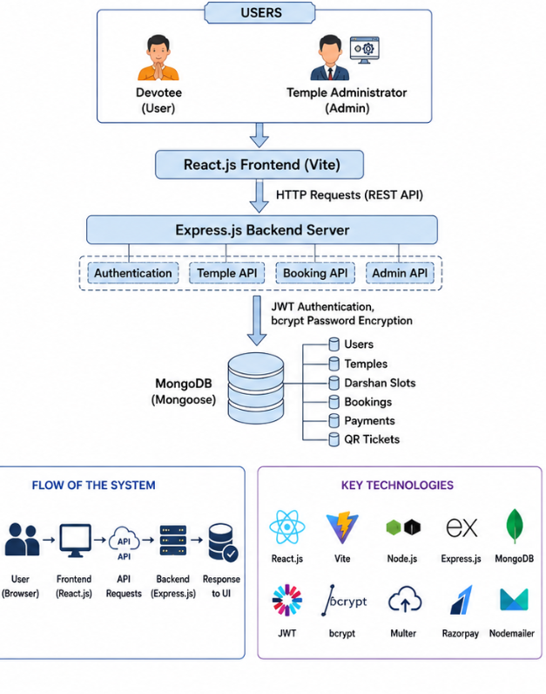

Table-1 : Components & Technologies:
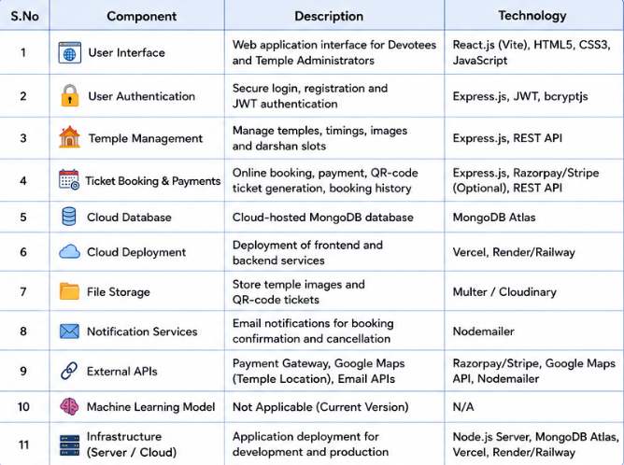

Table-2: Application Characteristics:
